clc;
clear all;

n=input('enter the total no. of readings "n" < 240 >=');
if n==[] % assigning the default n = 240
n=240;
end

s=input('enter the no. of readings in each subgroup "s" < 4 >=');
if s==[] % assigning the default s = 4
s=4;
end

disp('************************************************');
disp('Enter 1 -> To use the default values');
disp('Enter 2 -> To manually enter the data');
disp('************************************************');

ch=input('Enter your choice = ');

if ch==1
y=[10;30;17;30;37;45;14;18;28;45;25;10;32;28;30;31;16;34;8;32;
39;41;21;25;28;33;17;42;49;37;30;23;30;29;12;32;34;26;33;29;
34;18;43;56;27;22;19;49;48;28;20;30;18;27;20;23;18;40;31;58;
19;47;19;30;29;44;24;29;40;24;22;33;23;35;42;29;47;50;34;26;
45;23;26;26;27;24;38;55;19;34;18;43;37;18;30;7;28;18;16;28;
35;51;44;35;29;41;37;26;55;27;23;29;27;14;39;29;48;42;37;26;
41;21;27;14;20;28;14;40;37;36;18;49;28;34;31;32;39;42;27;33;
32;35;30;19;35;32;31;26;36;19;25;48;6;19;17;7;27;31;44;24;34;
28;38;40;17;5;23;17;12;22;51;4;16;24;29;21;22;28;35;41;24;16;
37;25;30;45;26;35;40;31;21;36;13;20;57;19;40;32;31;30;46;13;
31;35;30;15;21;30;52;27;36;20;41;34;36;26;18;30;34;32;8;45;17;
39;32;16;42;55;20;27;14;15;44;25;23;40;29;50;56;33];

k=1;
for i=1:n/s % n*s matrix making
for j=1:s
x(i,j)=y(k,1);
k=k+1;
end
end
end
if ch==2 % manual entering of the data
disp('Enter the data rowwise');
for i=1:n/s
for j=1:s
x(i,j)=input('data : ');
end
end
end
t(:,1)=mean(x,2); % mean of the data row wise (mean(x) gives column wise)
t(:,2)=std(x,1,2); % std(x,0,1) calculates std. for (sigma n-1)
t(:,3)=(range(x'))';

x(:,s+1)=t(:,1); % preparing the table
x(:,s+2)=t(:,2);
x(:,s+3)=t(:,3);

xdbar=mean(x(:,s+1)); % x double bar
sigmabar=mean(x(:,s+2)); %sigma bar
rbar=mean(x(:,s+3)); % r bar

disp('the Xdbar is =');
disp(xdbar);

disp('the Rbar is =');
disp(rbar);

disp('the sigmabar is =');
disp(sigmabar);

p=1:n/s;

% calculating data for the x bar-chart
a2=input('enter the data for "A2" from table C < s=4 > =');
if a2==[] % assigning the default a2 = 0.73
a2=0.73;
end
uclx=xdbar+a2*rbar;
lclx=xdbar-a2*rbar;

% calculating data for the range r-chart
d4=input('enter the data for "D4" from table C < s=4 > =');
if d4==[] % assigning the default d4 = 2.28
d4=2.28;
end
d3=input('enter the data for "D3" from table C < s<=6 > =');
if d3==[] % assigning the default d3 = 0
d3=0;
end
uclr=d4*rbar;
lclr=d3*rbar;

%calculating the data for the sigma bar chart
b4=input('enter the data for "B4" from table D < s=4 > =');
if b4==[] % assigning the default b4 = 2.57
b4=2.57;
end
b3=input('enter the data for "B3" from table D < s<=5 > =');
if b3==[] % assigning the default b3 = 0
b3=0;
end
uclsigma=b4*sigmabar;
lclsigma=b3*sigmabar;

% ploting all the three graphs
subplot(2,2,1);
plot(p,x(:,s+1),'r',p,xdbar,'+',p,lclx,'g',p,uclx,'g');
xlabel('subgroups');
ylabel('average');
title('XBAR CHART');

subplot(2,2,2);
plot(p,x(:,s+3),'r',p,rbar,'+',p,lclr,'g',p,uclr,'g');
xlabel('subgroups');
ylabel('range');
title('R-CHART');

subplot(2,2,3);
plot(p,x(:,s+2),'r',p,sigmabar,'+',p,lclsigma,'g',p,uclsigma,'g');
xlabel('subgroups');
ylabel('sigma');
title('SIGMA CHART');
disp(' data Xdbar sigmabar range');
disp(x);

OUTPUT

enter the total no. of readings "n" < 240 >=
enter the no. of readings in each subgroup "s" < 4 >=
************************************************
Enter 1 -> To use the default values
Enter 2 -> To manually enter the data
************************************************
Enter your choice = 1
the Xdbar is =
29.8542

the Rbar is =
22.6833

the sigmabar is =
8.7571

enter the data for "A2" from table C < s=4 > =
enter the data for "D4" from table C < s=4 > =
enter the data for "D3" from table C < s<=6 > =
enter the data for "B4" from table D < s=4 > =
enter the data for "B3" from table D < s<=5 > =

data Xdbar sigmabar range
10.0000 30.0000 17.0000 30.0000 21.7500 8.6132 20.0000
37.0000 45.0000 14.0000 18.0000 28.5000 12.8938 31.0000
28.0000 45.0000 25.0000 10.0000 27.0000 12.4298 35.0000
32.0000 28.0000 30.0000 31.0000 30.2500 1.4790 4.0000
16.0000 34.0000 8.0000 32.0000 22.5000 10.8972 26.0000
39.0000 41.0000 21.0000 25.0000 31.5000 8.6458 20.0000
28.0000 33.0000 17.0000 42.0000 30.0000 9.0277 25.0000
49.0000 37.0000 30.0000 23.0000 34.7500 9.6014 26.0000
30.0000 29.0000 12.0000 32.0000 25.7500 8.0117 20.0000
34.0000 26.0000 33.0000 29.0000 30.5000 3.2016 8.0000
34.0000 18.0000 43.0000 56.0000 37.7500 13.8271 38.0000
27.0000 22.0000 19.0000 49.0000 29.2500 11.7553 30.0000
48.0000 28.0000 20.0000 30.0000 31.5000 10.2347 28.0000
18.0000 27.0000 20.0000 23.0000 22.0000 3.3912 9.0000
18.0000 40.0000 31.0000 58.0000 36.7500 14.5495 40.0000
19.0000 47.0000 19.0000 30.0000 28.7500 11.4537 28.0000
29.0000 44.0000 24.0000 29.0000 31.5000 7.5000 20.0000
40.0000 24.0000 22.0000 33.0000 29.7500 7.2241 18.0000
23.0000 35.0000 42.0000 29.0000 32.2500 7.0489 19.0000
47.0000 50.0000 34.0000 26.0000 39.2500 9.7308 24.0000
45.0000 23.0000 26.0000 26.0000 30.0000 8.7464 22.0000
27.0000 24.0000 38.0000 55.0000 36.0000 12.1450 31.0000
19.0000 34.0000 18.0000 43.0000 28.5000 10.5000 25.0000
37.0000 18.0000 30.0000 7.0000 23.0000 11.4673 30.0000
28.0000 18.0000 16.0000 28.0000 22.5000 5.5453 12.0000
35.0000 51.0000 44.0000 35.0000 41.2500 6.7222 16.0000
29.0000 41.0000 37.0000 26.0000 33.2500 6.0156 15.0000
55.0000 27.0000 23.0000 29.0000 33.5000 12.5996 32.0000
27.0000 14.0000 39.0000 29.0000 27.2500 8.8987 25.0000
48.0000 42.0000 37.0000 26.0000 38.2500 8.0739 22.0000
41.0000 21.0000 27.0000 14.0000 25.7500 9.9342 27.0000
20.0000 28.0000 14.0000 40.0000 25.5000 9.7340 26.0000
37.0000 36.0000 18.0000 49.0000 35.0000 11.0680 31.0000
28.0000 34.0000 31.0000 32.0000 31.2500 2.1651 6.0000
39.0000 42.0000 27.0000 33.0000 35.2500 5.7609 15.0000
32.0000 35.0000 30.0000 19.0000 29.0000 6.0415 16.0000
35.0000 32.0000 31.0000 26.0000 31.0000 3.2404 9.0000
36.0000 19.0000 25.0000 48.0000 32.0000 11.0680 29.0000
6.0000 19.0000 17.0000 7.0000 12.2500 5.8041 13.0000
27.0000 31.0000 44.0000 24.0000 31.5000 7.6322 20.0000
34.0000 28.0000 38.0000 40.0000 35.0000 4.5826 12.0000
17.0000 5.0000 23.0000 17.0000 15.5000 6.5383 18.0000
12.0000 22.0000 51.0000 4.0000 22.2500 17.7817 47.0000
16.0000 24.0000 29.0000 21.0000 22.5000 4.7170 13.0000
22.0000 28.0000 35.0000 41.0000 31.5000 7.1589 19.0000
24.0000 16.0000 37.0000 25.0000 25.5000 7.5000 21.0000
30.0000 45.0000 26.0000 35.0000 34.0000 7.1063 19.0000
40.0000 31.0000 21.0000 36.0000 32.0000 7.1063 19.0000
13.0000 20.0000 57.0000 19.0000 27.2500 17.3835 44.0000
40.0000 32.0000 31.0000 30.0000 33.2500 3.9607 10.0000
46.0000 13.0000 31.0000 35.0000 31.2500 11.8822 33.0000
30.0000 15.0000 21.0000 30.0000 24.0000 6.3640 15.0000
52.0000 27.0000 36.0000 20.0000 33.7500 11.9661 32.0000
41.0000 34.0000 36.0000 26.0000 34.2500 5.4025 15.0000
18.0000 30.0000 34.0000 32.0000 28.5000 6.2249 16.0000
8.0000 45.0000 17.0000 39.0000 27.2500 15.2377 37.0000
32.0000 16.0000 42.0000 55.0000 36.2500 14.2544 39.0000
20.0000 27.0000 14.0000 15.0000 19.0000 5.1478 13.0000
44.0000 25.0000 23.0000 40.0000 33.0000 9.1378 21.0000
29.0000 50.0000 56.0000 33.0000 42.0000 11.2916 27.0000
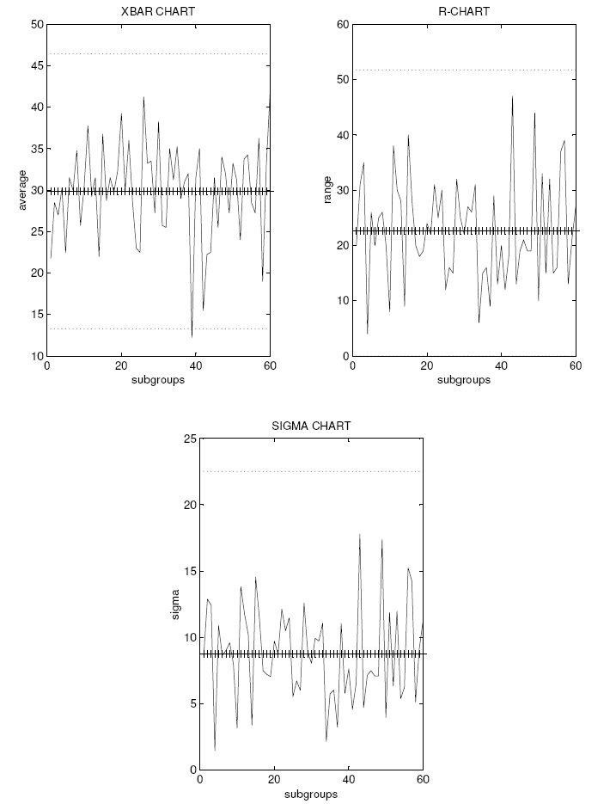

PART PROGRAM FOR STEP TURNING

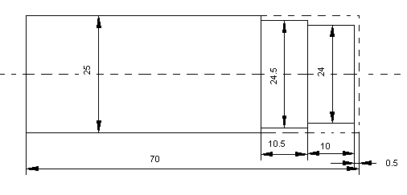

[BILLET X25 Y70
G21 G97 G98 (metric data input, constant rpm, feed/min.)
G28 U0 W0 (tool to home via incremental (0, 0) position)
M6 T01 (tool change, roughing tool)
M03 S1500 (spindle cw, speed 1500 rpm)
G00 X26 Z1 (rapid traverse to (26, 1) position)
G01 X24.7 Z1 F20 (linear interpolation only in x direction, feed=20mm/min.)
G01 Z-20.5 (cutting starts, linearly (24.7,-20.5), d.o.c. =0.3mm)
G01 X26 (tool out of workpiece)
G00 X25 Z1 (rapid traverse to (25, 1))
G01 X24.5 Z1 (positioning the tool for the next cut)
G01 Z-20.5 (cuts first step with d.o.c= 0.2mm upto -20.5)
G01 X25
G00 Z1
G01 X24.2 (next step cutting starts d.o.c= 0.3mm)
G01 Z-10.5 (next step cuts upto -10.5)
G01 X25 (repositioning of the tool for the next cut)
G00 Z1
G01 X24 (cutting d.o.c= 0.2 mm upto -10.5)
G01 Z-10.5
G01 X25 (repositioning of the tool for facing)
G00 Z0
G01 Z-0.3 (facing starts with d.o.c= 0.3mm)
G01 X0
G01 Z-0.5 (facing again with d.o.c= 0.2 mm)
G01 X25
G28 (tool to home)
M05 (spindle stop)
M30 (rewind)

PART PROGRAM FOR STEP TURNING USING TURNING & FACING CANNED CYCLE (G90 & G 94)

[BILLET X25 Y70
G21 G97 G98 (metric, mm/min,)
G28 U0 W0 (tool to home via. incremental 0, 0)
M06 T01 (tool change, roughing tool selected)
M03 S1500 (spindle starts, speed 1500 rpm)
G00 X26 Z1 (rapid traverse tool to position (26, 1))
G90 X24.7 Z-20.5 F10 (single turning cycle, feed 10mm/min.)
X24.5 Z-20.5 (first step cutting starts upto -20, final dia. =24.5)
X24.2 Z-10.5 (second step cutting d.o.c= 0.3mm)
X24 Z-10.5 (d.o.c= 0.2 mm, step is upto -10, final dia. =24))
G94 X0 Z-0.3 (single facing cycle)
X0 Z-0.5 (facing 0f 0.5mm material)
G28 U0 W0 (tool to home by incremental (0, 0))
M05 (spindle stop)
M30 (rewind)

PART PROGRAM FOR TAPER TURNING USING CANNED CYCLE G90 (SINGLE TURNING CYCLE)

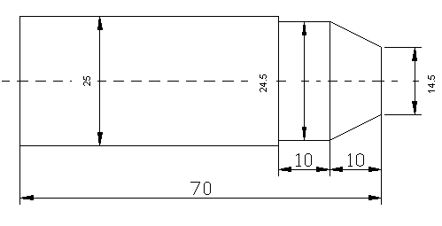

[BILLET X25 Y70
G21 G97 G98 (metric data,constant speed,feed/min.)
G28 U0 W0 (tool to home)
M06 T01 (tool change, roughing tool)
M03 S1500 (spindle starts, speed 1500 rpm)
G00 X26 Z1 (rapid traverse to position)
G90 X24.7 Z-20 F10 (single turning cycle starts, feed = 10 mm/min.)
X24.5 Z-20 (step turning upto -20 ends, final dia. =24.5)
X24.5 Z-10 R-0.3 (taper turning starts with retract value 0.3)
X24.5 Z-10 R-0.6 (taper turning upto -10)
X24.5 Z-10 R-0.9
X24.5 Z-10 R-1.2
X24.5 Z-10 R-1.5
X24.5 Z-10 R-1.8
X24.5 Z-10 R-2.1
X24.5 Z-10 R-2.4
X24.5 Z-10 R-2.7 (taper turning continues)
X24.5 Z-10 R-3.0
X24.5 Z-10 R-3.3
X24.5 Z-10 R-3.6
X24.5 Z-10 R-3.9
X24.5 Z-10 R-4.2
X24.5 Z-10 R-4.5
X24.5 Z-10 R-4.8
X24.5 Z-10 R-5.0 (taper turning ends with final retract value= 5 & dia. =14.5)
G28 U0 W0 (tool to home)
M05 (spindle stops)
M30 (rewind)

PART PROGRAM FOR CANNED CYCLE G71 (MULTIPLE TURNING CYCLE)

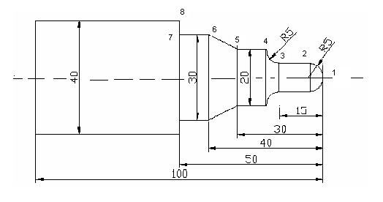

[BILLET X40 Z100
G21 G97 G98 (metric data, constant speed, feed mm/min.)
G28 U0 W0 (tool to home)
M06 T01 (tool change, roughing tool)
M03 S1500 (spindle starts cw., speed 1500 rpm)
G00 X41 Z1 (rapid traverse tool to position (41, 1))
G71 U0.8 R0.5 (multiple turning cycle, d.o.c= 0.8 mm, retract value= 0.5mm)
G71 P10 Q20 U0.1 W0.1 F20 (geometry define from 10 - 20, finishing allowance=0.1mm)
N10 G00 X0 (geometry definitions starts, feed= 20 mm/min.)
G01 Z0 (point 1)
G03 X10 Z-5 R5 (point 2, circular interpolation ccw, radius=5mm)
G01 X10 Z-15 (point 3, linear interpolation)
G02 X20 Z-20 R5 (point 4, circular interpolation cw, radius =5)
G01 X20 Z-30 (point 5, linear cutting, feed= 20mm/min.)
G01 X30 Z-40 R5 (point 6, taper turning, retract value=5)
G01 X30 Z-50 (point 7, dia. = 30mm)
N20 G01 X40 Z-50(point 8, dia. = 40mm, geometry definition ends)
G28 U10 W0 (tool to home)
M05 (spindle stops)
M30 (rewind)

PART PROGRAM FOR CANNED CYCLE G72 (MULTIPLE FACING CYCLE)

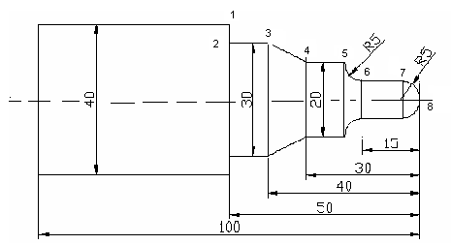

[BILLET X40 Z100
G21 G97 G98 (metric data, constant speed, feed mm/min.)
G28 U0 W0 (tool to home)
M06 T01 (tool change, roughing tool)
M03 S1500 (spindle starts cw., speed 1500 rpm)
G00 X41 Z1 (rapid traverse tool to position (41, 1))
G72 U0.8 R0.5 (multiple facing cycle, d.o.c= 0.8 mm, retract value= 0.5mm)
G72 P10 Q20 U0.1 W0.1 F20 (finishing allowance = 0.1 mm, retract value= 0.5mm)
N10 G00 Z-50 (geometry definitions starts, feed= 20 mm/min.)
G01 X40 (point 1)
G01 X30 Z-50 (point 2)
G01 X30 Z-40 (point 3, linear interpolation)
G01 X20 Z-30 R5 (point 4, retract value =5)
G01 X20 Z-20 (point 5, linear cutting, feed= 20mm/min.)
G03 X10 Z-15 R5 (point 6, circular interpolation ccw., radius =5)
G01 X10 Z-5 (point 7, dia. = 10mm)
N20 G02 X0 Z0 R5 (point 8, circular interpolation ccw., geometry definition ends)
G28 U0 W0 (tool to home)
M05 (spindle stops)
M30 (rewind)

PART PROGRAM FOR GROOVING, DRILLING & FOR CANNED CYCLE G73 (PATTERN REPEATING CYCLE)
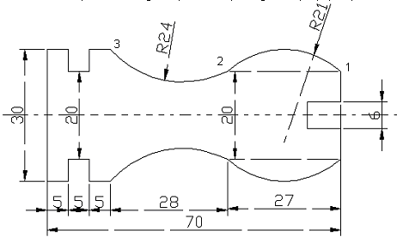

[BILLET X30 Z70
G21 G97 G98 (metric data, const. speed, feed mm/min.)
G28 U0 W0 (tool to home)
M06 T04 (tool change to 6mm drill)
M03 S1500 (spindle cw., 1500rpm)
G00 X0 Z2
G01 X0 Z-8 F10 (drill to -8mm depth)
Z2
G28 U2 W0 (drill to home)
M06 T01 (tool change to turning tool)
G00 X32 Z2
G73 U7 W4 R10 (x-axis & y-axis relief to 7 & 3, cycles =10)
G73 P10 Q20 U0.1 W0.1 F10 (geometry 10 to 20, allowance 0.1mm)
N10 G00 X20 (feed 10mm/min.)
G01 Z0 (point 1)
G03 X20 Z-27 R21 (point 2, ccw. cutting)
N20 G02 X30 Z-55 R24 (point 3, cw. cutting)
G28 U2 W0 (roughing tool to home)
M06 T03 (tool change to 2mm grooving tool)
G00 X32 Z-65 (positioning tool to location)
G01 X20 F10 (first cutting groove =2mm)
X32
Z-63
X20 (second cutting =2mm, groove =4mm)
X32
Z-62
X20 (third cutting =1mm, groove =5mm)
X32
G28 U5 W0 (grooving tool to home)
M05 (spindle stop)
M30 (rewind)

PART PROGRAM FOR MILING

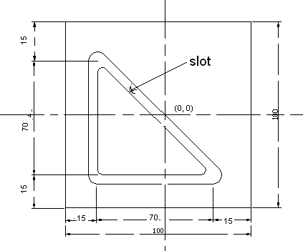

[BILLET X100 Y100 Z10
[EDGEMOVE X-50 Y-50 (move the lower left edge to position w.r.t datum)
G21 G94 G91 (metric data, feed mm/min., incremental values)
G28 X0 Y0 Z0 (tool to home via. z0)
M06 T01 (tool change)
M03 S2000 (spindle cw., speed 2000rpm)
G90 (absolute dimensions given)
G00 X0 Y0 Z40 (absolute positioning of the tool)
G00 X-35 Y35 Z40
Z2
G01 Z-2 F10 (feed =10mm/min. d.o.c =2mm)
G91 (incremental dimensions ahead)
G01 Y-70 F10 (cutting linearly to required dimensions)
X70
X-70 Y70
G02 X70 Y-70 R50 (cw. circular cutting)
G00 Z100
M05 (spindle stop)
G28 X0 Y0 Z0 (tool to home)
M30 (rewind)

PART PROGRAM FOR MILING

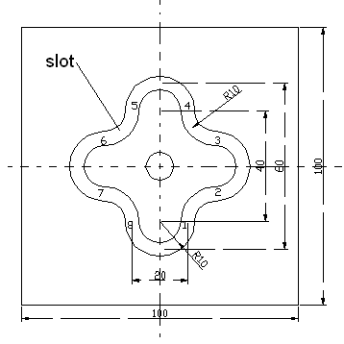

[BILLET X100 Y100 Z10
[EDGEMOVE X-50 Y-50 (move the lower left edge to position w.r.t datum)
G21 G94 G90 (metric data, feed mm/min., absolute values)
G28 Z10 (tool to home via. z10)
M06 T01 (tool change)
M03 S1500 (spindle cw., speed 1500rpm)
G00 X0 Y0 Z2 (abs. positing of tool to (0, 0, 2))
G01 Z-2 F10 (making a hole on the billet)
Z2
G00 X10 Y-20 (repositioning of the tool to point 1)
G01 Z-2 F10 (d.o.c =2mm/min., feed =10mm/min.)
G02 X20 Y-10 R10 (point 2, cw. cutting, radius 10)
G03 Y10 R10 (point 3, ccw. cutting)
G02 X10 Y20 (point 4, cw. cutting)
G03 X-10 R10 (point 5, ccw. cutting)
G02 X-20 Y10 (point 6, cw. cutting)
G03 Y-10 (point 7, ccw. cutting, radius =10mm everywhere)
G02 X-10 Y-20 (point 8, cw. cutting)
G03 X10 (point 1, ccw. cutting)
G01 Z2 (retraction of the tool from the workpiece)
G28 X0 Y0 Z10 (tool to home via. (0, 0, 10))
M05 (spindle stop)
M30 (rewind)

PART PROGRAM FOR MIRRORING

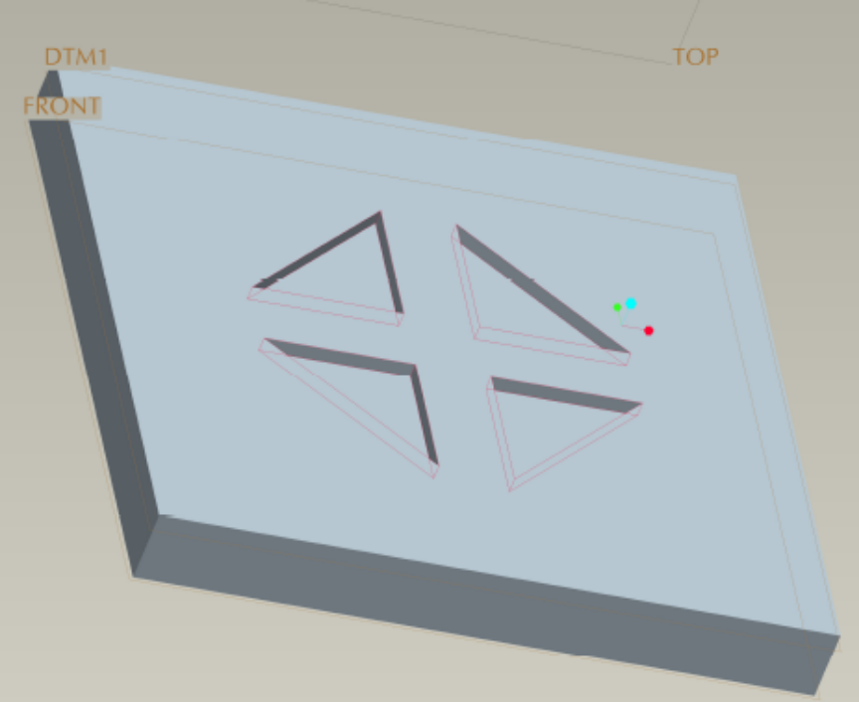

[BILLET X90 Y90 Z10
[EDGEMOVE X-45 Y-45
G21 G94 G91
SUBPROGRAM NO. 0001

G00 X5 Y5
G01 Z0 F20
G01 Z-2
X5 Y25
X35 Y5
X5
G00 Z2
X0 Y0
M99

G28 X0 Y0 Z0
M06 T01
M03 S2000
G90
G00 X0 Y0 Z0
Z2
M98 P0001
M70
M98 P1
M80
M71
M98 P1
M70
M98 P1
M80
M81
M05
G91
G28 Z0
G28 X0 Y0 Z0
M30

USING SUBPROGRAM & CIRCULAR & RECTANGUALR POCKETING

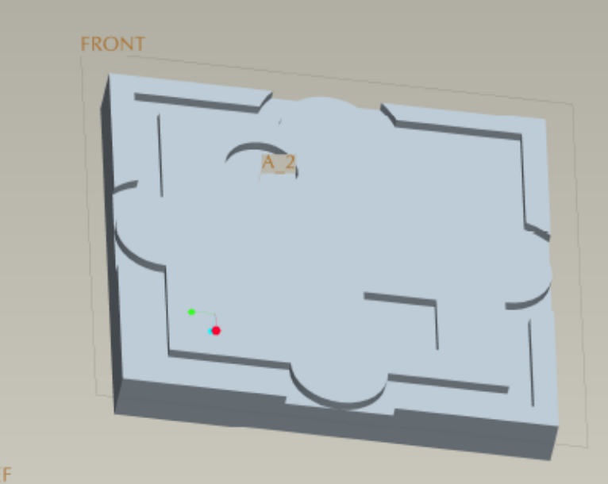

[BILLET X90 Y90 Z10
Subprogram (no. 0002) for the program no. 220005

G90
G42
G00 X45 Y0
G01 Z-2 F60
G03 X35 Y10 R10
G01 Y35
X10
G03 X0 Y45 R10
G01 Z2
G40
G00 X0 Y0
M99

[EDGEMOVE X-45 Y-45
G21 G94 G91
G28 X0 Y0 Z0
M06 T01
M03 S2000
G90
G00 X0 Y0 Z2
M98 P0002
M70
M98 P0002
M80
M71
M98 P0002
M70
M98 P0002
M80
M81
G90
G00 X-10 Y10
G170 R0 P0 Q0.5 X-10 Y10 Z-2 I.2 J.2 K9
G171 P100 S2000 R35 F45 B2500 J50
G172 I15 J15 K0 P0 Q.5 R0 X10 Y-23 Z-2
G173 I.2 K.2 P100 T1 S2000 R35 F60 B2500 J50 Z5
G91
G28 X0 Y0 Z0
M05
M30

